CROC_chaud single 50-pin connector:

Pinout:
erased MISO → MOSI (pin 33?) / only when taking measurement
MISO (pin 30) / both when taking meas and when requesting 96-bit register
SCLK (pin 31) 96 pulses when taking meas / 1 + 96 when requesting
LOAD () both when meas and requesting. When requesting first 96-pulses to load and then READ
READ (pin ) after LOAD when requesting.

The above signals are CMOS with low=0V and high=3.3V.

With yellow color is always the SCLK.
Start a measurement
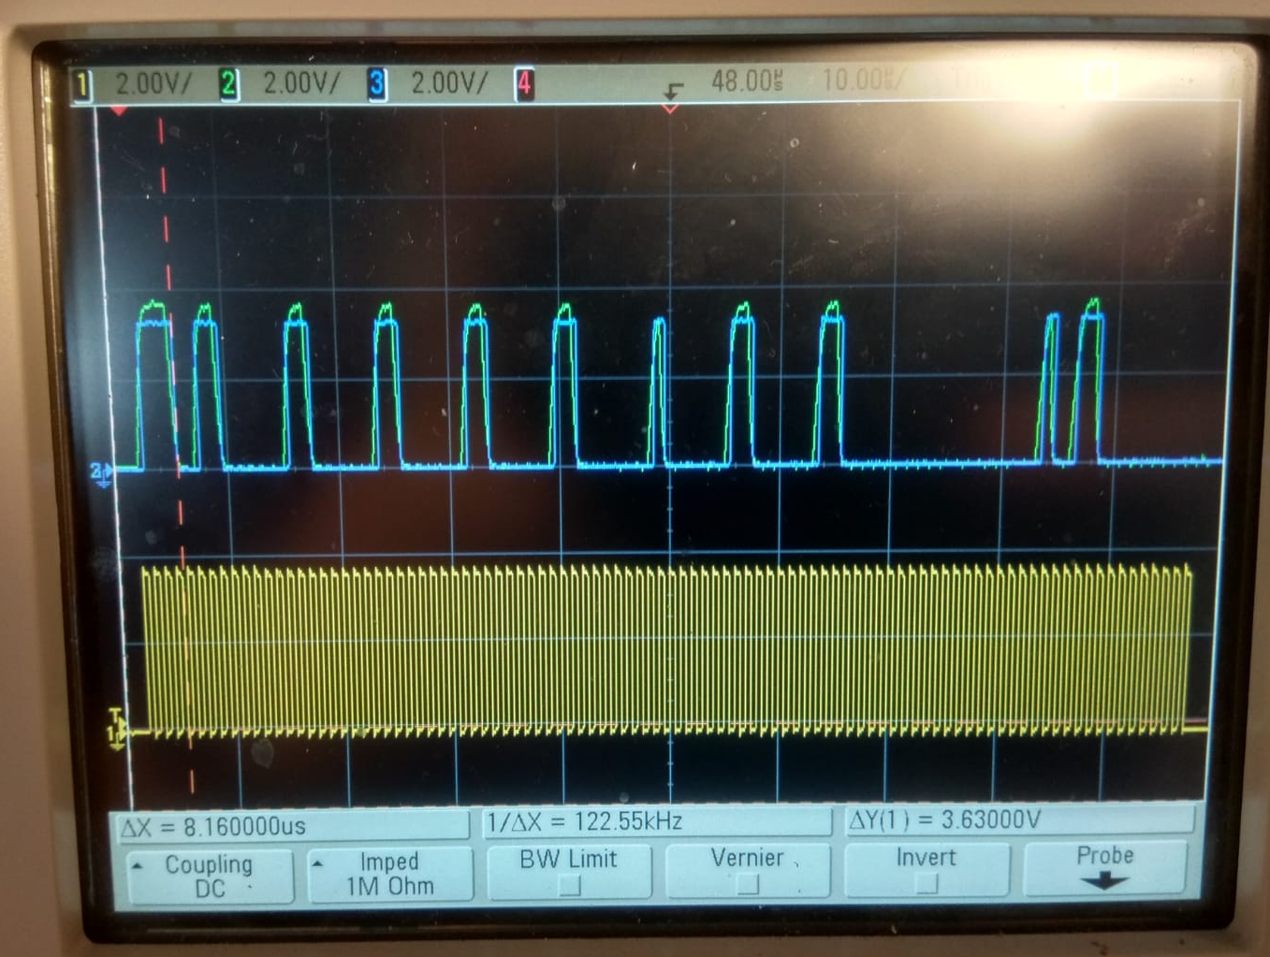
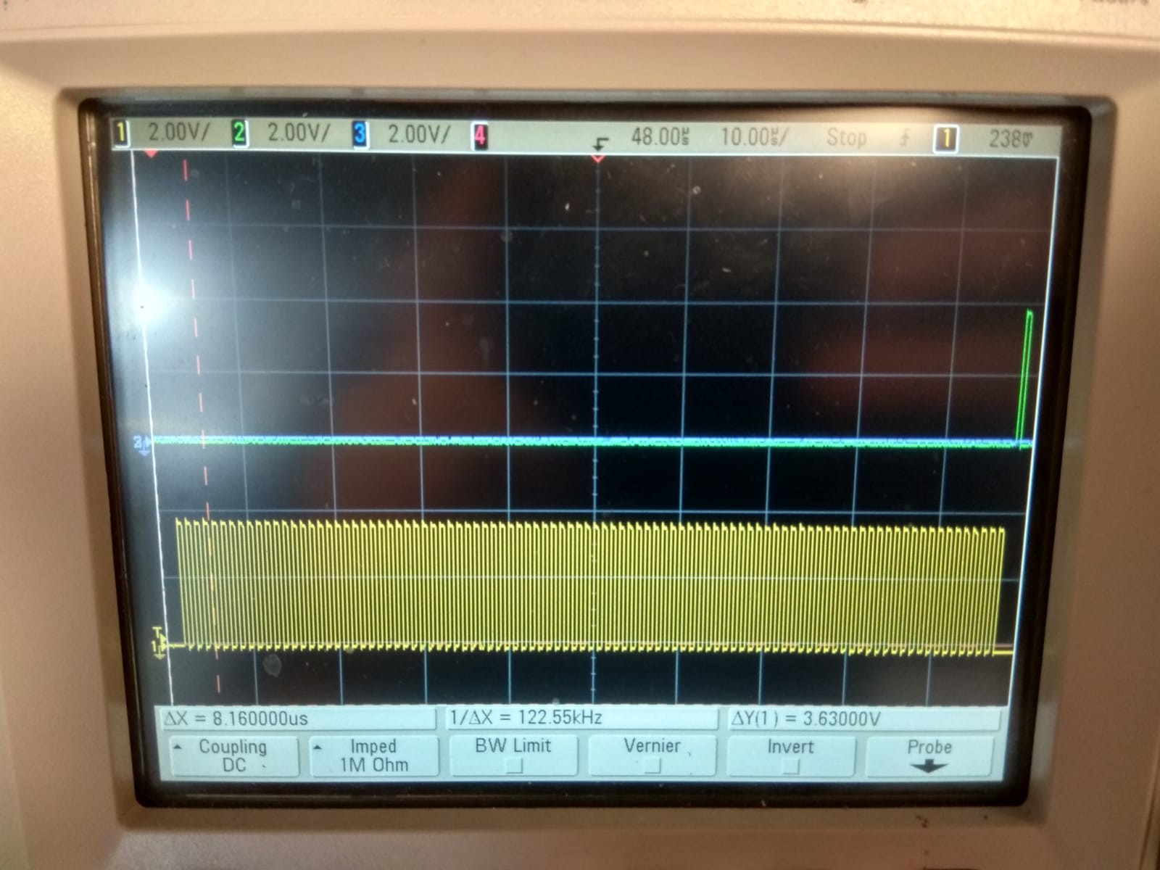
Right image: Blue→MOSI, Green→MISO Left image: Blue→READ, Green→LOAD

Readback CROC register (2 phases)
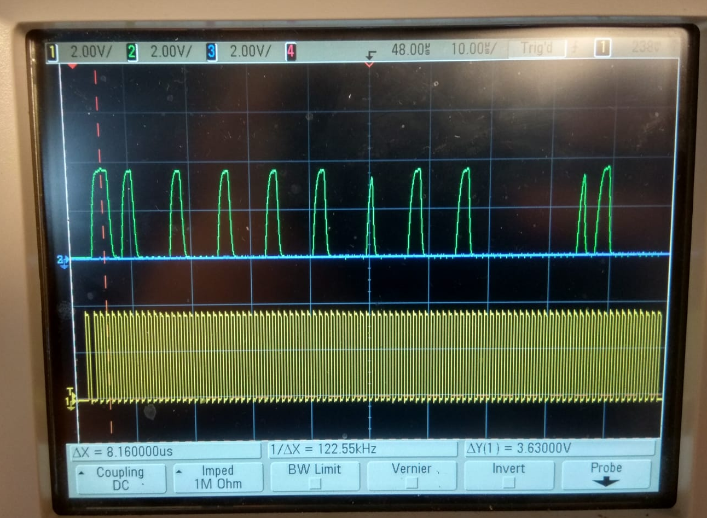
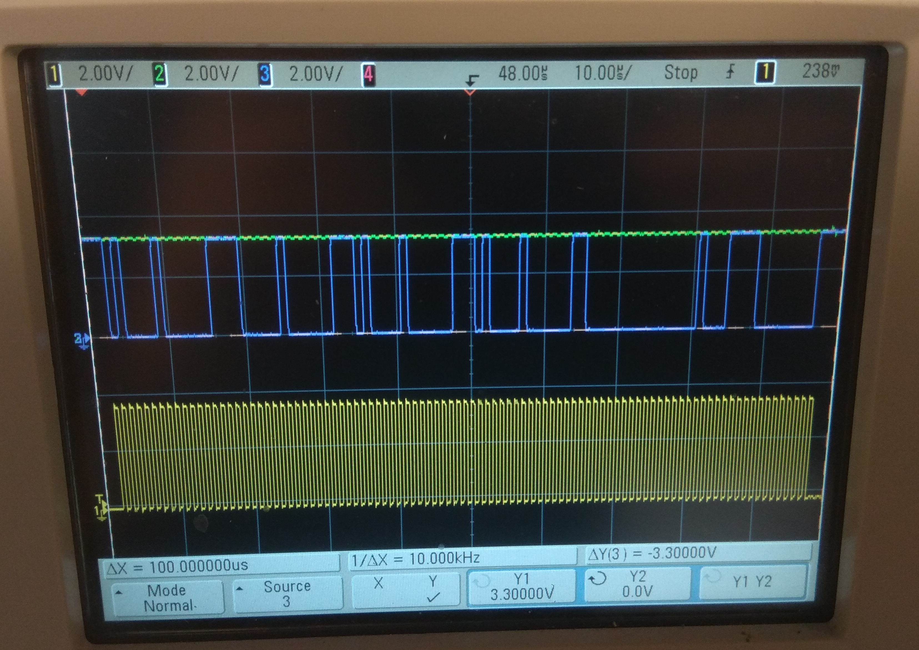
First the new parameters are sent as 96-bit word (left) and then takes place the readback (right)
1st phase: MOSI (blue) signal is sent. No MISO (green) is returned.
2nd phase: No MOSI (blue) signal is sent. Only MISO (green) is returned. (different BEB3s)
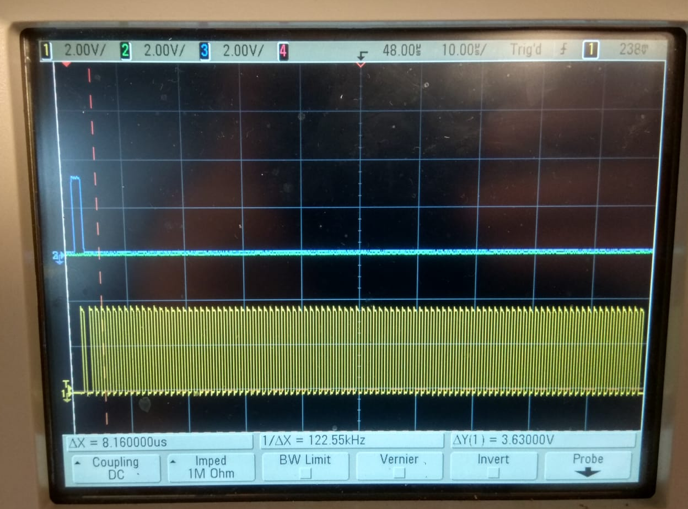
Readback has two phases: 1st (left), 2nd (right). Signals: LOAD (green), READ (blue)

Between the 2 phases there is time window of ~20ms.
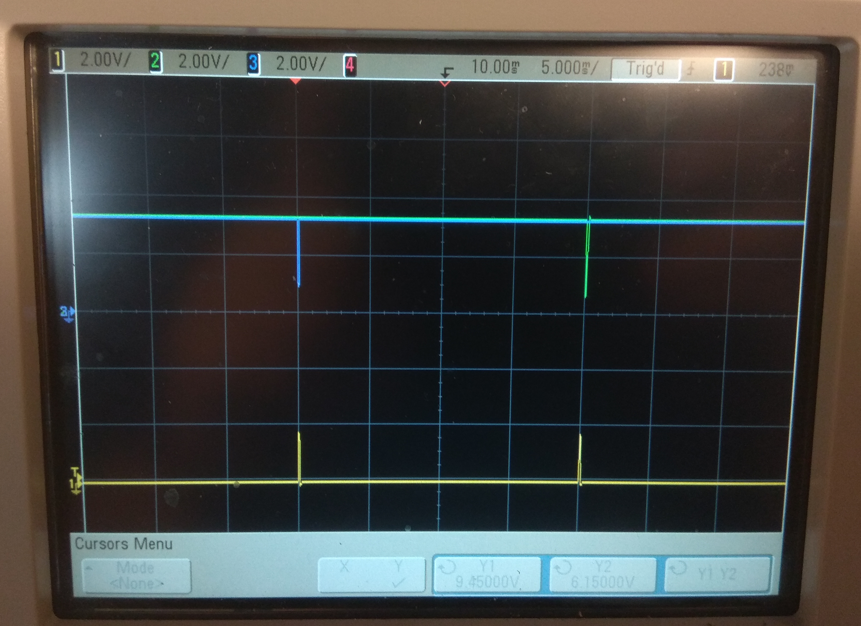

To do:
- What is the delay between the phase 1 & 2 of Readback? 20ms
- Check the nReset pulse with the CROC setup.
- Verify the low and high values of the signals. 0 to 3.3V
- Check the MISO, MOSI during the phase 1 of Readback. Only MOSI is sent, no MISO
- Check when the MISO/MOSI set the bit, at the raise or the fall of the SCLK pulse. raise

- Look at the Clamp and get both the differential signals and the difference of them (single ended).

